**Design related tools and frameworks:**

In designing the collaborative e-learning platform, we will be using a combination of Bootstrap, HTML5, and Vue.js. These tools offer a powerful and flexible framework for creating a dynamic and engaging user interface.

pasted-image.tiff

Bootstrap will be used to create a responsive and consistent design across all devices and screen sizes. Its pre-built UI components and layout options will provide a solid foundation for the platform's look and feel.

pasted-image.tiff

HTML5 will provide the underlying structure for the platform's pages and will be used to create the content, such as text, images, and videos. Additionally, HTML5 will provide the functionality for

the questions and assessments, allowing for dynamic and interactive content.

pasted-image.tiff

Vue.js will be used to create a reactive and dynamic user interface, allowing for real-time updates and interactions. With Vue.js, we can create dynamic and responsive user interfaces that are easy to maintain and scale.

By using these tools together, we can create a collaborative e-learning platform that is visually appealing, easy to use, and highly interactive. The platform will provide a seamless and engaging experience for students, regardless of their device or screen size, and will allow them to learn at their own pace and on their own schedule.

**Designing process**:

The design process for the front-end of the collaborative e-learning platform involved using Sublime Text as the code editor, and Chrome as the browser for viewing the WYSIWYG (What You See Is What You Get) results.

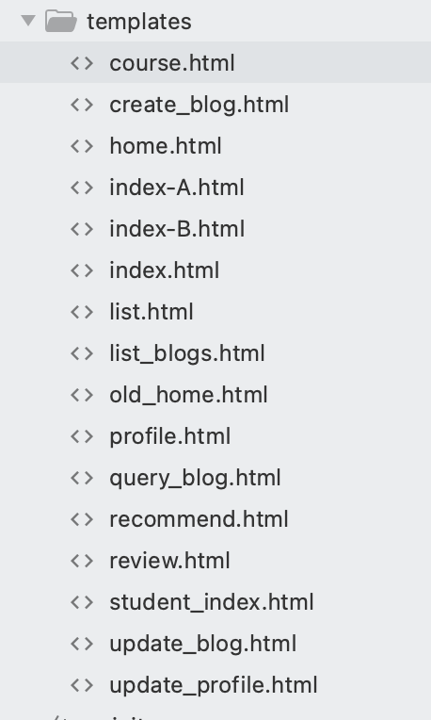

The first step in the process was to write the code using the Vue.js, HTML5, and Bootstrap frameworks. This involved creating the layout and structure of the platform's pages, including the homepage, course pages, and lesson pages, as well as incorporating the interactive quizzes and assessments.

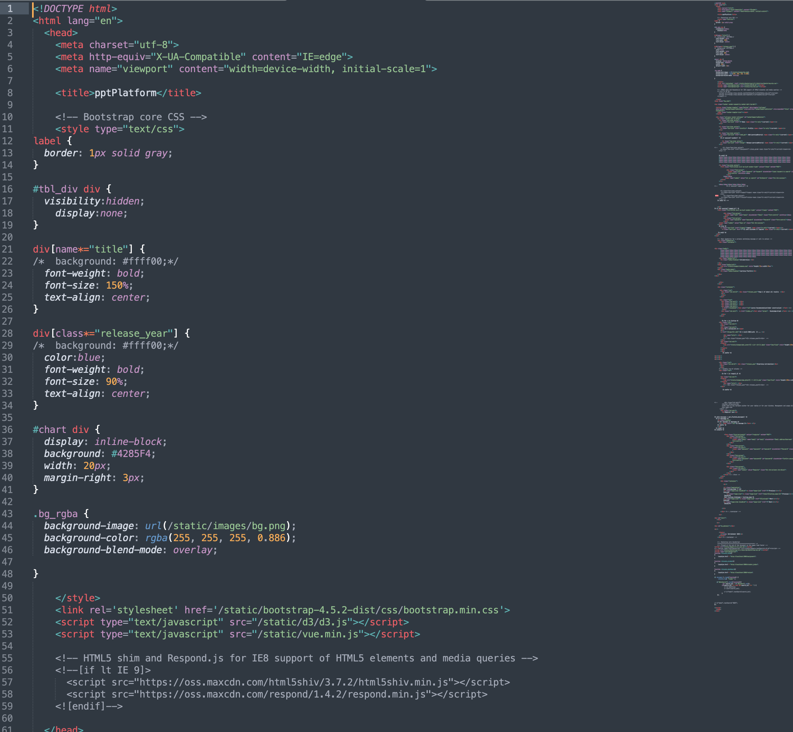

Once the code was written, it was viewed in Chrome to see the results of the WYSIWYG. This allowed us to see how the platform would look and feel as it would be viewed by the end-users. Any necessary adjustments were made to the code at this stage, and the changes were immediately reflected in the browser.

After the initial WYSIWYG view, the platform was adapted for both PC and mobile devices. This involved making any necessary adjustments to the layout and design to ensure a consistent and seamless user experience across all devices. The code was then refined and optimized for performance and stability.

Throughout the design process, we made use of browser debugging tools to identify and resolve any issues with the platform's functionality. This helped to ensure a smooth and seamless user experience for all users.

In conclusion, the design process for the collaborative e-learning platform involved using Sublime Text as the code editor, Chrome as the browser for viewing the WYSIWYG results, and Vue.js, HTML5, and Bootstrap as the frameworks for the front-end. The process involved writing and refining the code, adapting it for both PC and mobile devices, and using debugging tools to resolve any issues. The result is a highly functional, visually appealing, and easy-to-use platform that provides a seamless and engaging experience for all users.

**Design and Detailed Specification:**

1. User Experience: The platform should have a clean, intuitive, and user-friendly interface that is easily navigable by users of all ages and backgrounds. The design should be visually appealing and modern, with attention to detail.
2. Content Management System (CMS): The platform should have a robust CMS that allows administrators to upload and manage course content, including videos, audio recordings, images, and text-based materials. The CMS should also have a feature that allows instructors to add interactive quizzes and assessments.( mainly the listing of all learning material)
3. Managing Material UI: The design of adding, deleting, modifying, and checking the learning materials is a crucial aspect of the collaborative e-learning platform. This feature enables educators and administrators to manage the content that is available to the students, ensuring that it is up-to-date, relevant, and of high quality. The first step in the design process is to provide an interface for adding new learning materials. This can be done through a simple and intuitive form that collects the necessary information, such as the title, description, and file attachments. Once the information has been entered, the new learning material is added to the platform's database, and it becomes immediately available to students.The next step is to provide an interface for modifying existing learning materials. This can be accomplished by clicking on the learning material in question, and then editing its information through a form. This allows educators and administrators to make updates and revisions to the content, ensuring that it remains accurate and relevant. In addition to adding and modifying learning materials, the platform must also provide the ability to delete them. This can be accomplished by selecting the learning material in question and clicking on a "delete" button. Once deleted, the learning material will no longer be available to students. Finally, the platform must provide a way for administrators and educators to check the learning materials that are available on the platform. This can be done through a simple search interface that allows them to search for learning materials based on keywords, titles, or other criteria. The results of the search can be displayed in a list or table, making it easy for administrators to view and manage the content.In conclusion, the design of adding, deleting, modifying, and checking the learning materials is a crucial aspect of the collaborative e-learning platform. This feature enables educators and administrators to manage the content that is available to the students, ensuring that it is up-to-date, relevant, and of high quality. The design process involves creating interfaces for adding, modifying, and deleting learning materials, as well as providing a search interface for checking and managing the content. The result is a platform that is easy to use and maintain, ensuring a seamless and engaging learning experience for all students.)
4. File Upload System: The design of uploading materials is a critical component of the collaborative e-learning platform, as it allows educators and administrators to add and manage the content that is available to the students. The platform must be able to handle a variety of different file types, including PDFs, videos, and images, ensuring that the content is diverse, engaging, and accessible to all students. The first step in the design process is to provide an interface for uploading the materials. This can be done through a simple form that collects the necessary information, such as the title, description, and file attachments. The form should allow for the selection of the file type, including PDF, video, and image files. Once the information has been entered, the file attachments are uploaded to the platform's database and are immediately available to students. To ensure the quality of the content, the platform must also provide the ability to preview the uploaded materials. This can be accomplished by integrating a preview feature into the upload form. This allows educators and administrators to view the content before it becomes available to students, ensuring that it is of high quality and appropriate for the target audience.In addition to uploading the materials, the platform must also provide the ability to manage the content. This can be done through a simple interface that allows educators and administrators to view, edit, and delete the content. This ensures that the content remains up-to-date, relevant, and of high quality. The platform must also be able to handle large file sizes and provide fast and reliable upload speeds. This can be accomplished by using technologies such as cloud storage, which enables the platform to scale as needed, providing ample storage space and fast upload speeds for the content. Finally, the platform must be secure, protecting the privacy and confidentiality of the uploaded content. This can be achieved through the use of encryption and other security measures, such as firewalls, access control, and backup and disaster recovery protocols.In conclusion, the design of uploading materials is a critical component of the collaborative e-learning platform. The platform must be able to handle a variety of different file types, including PDFs, videos, and images, ensuring that the content is diverse, engaging, and accessible to all students. The design process involves providing an interface for uploading the materials, integrating a preview feature, providing the ability to manage the content, handling large file sizes and providing fast and reliable upload speeds, and ensuring the platform's security. The result is a platform that provides a seamless and engaging learning experience for all students, with high-quality and up-to-date content.
5. User Dashboard: Each user should have a personalized dashboard that displays their progress in each course, including which lessons they have completed and the scores they received on quizzes and assessments.
6. Comments on Learning Material: Users should be able to leave comments and feedback on the course content and interact with other students taking the course. The comments should be moderated by instructors or administrators to ensure a positive and respectful learning environment. （这块还要补充 ）

**Storyboard Design**:

1. Homepage: The homepage should have a clean, modern design and provide an overview of the platform and its features. The homepage should include a call to action to sign up or log in.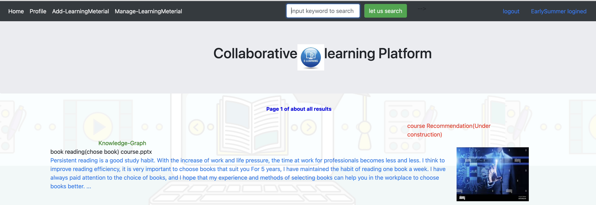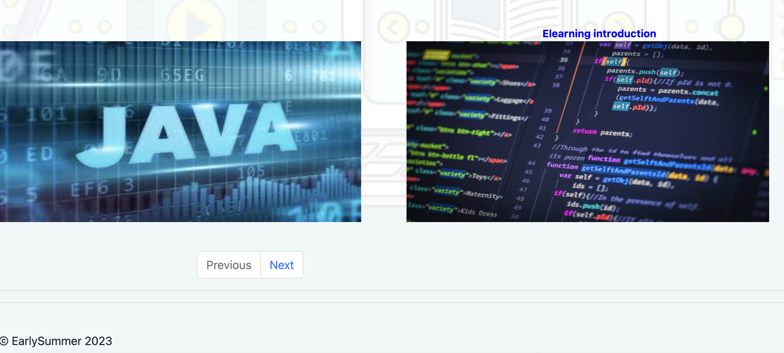
2. Course Page: The course page should provide detailed information about a specific course, including the instructor, course description, and a list of lessons. Users should be able to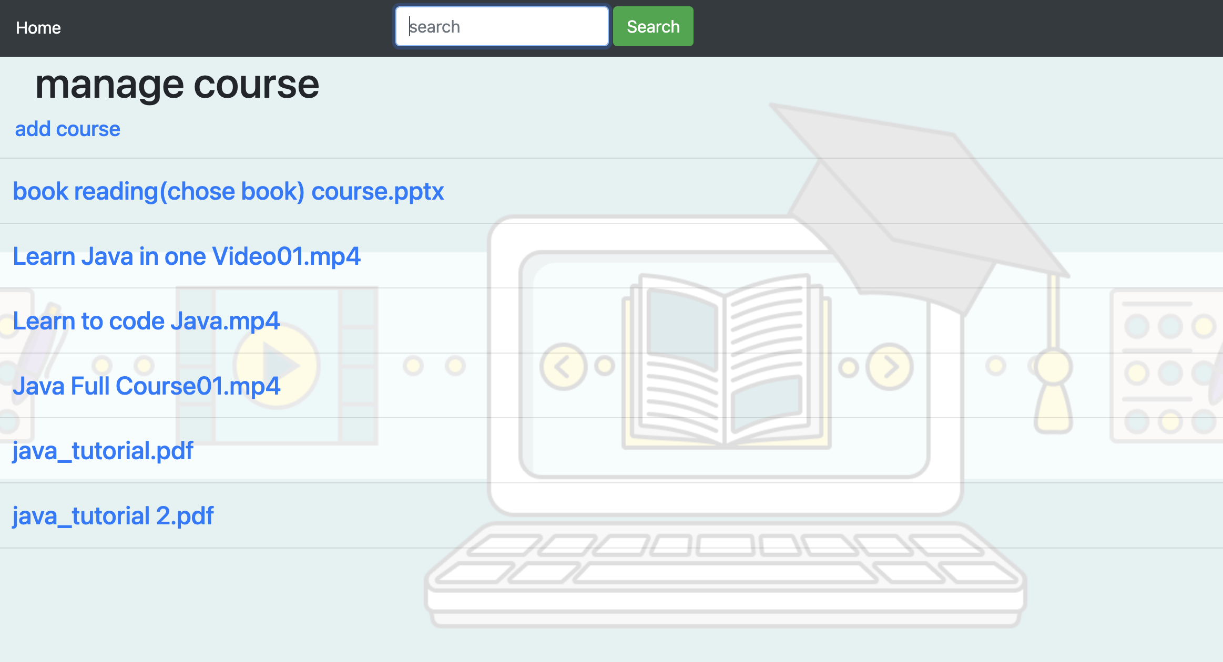 preview a course before enrolling.
3. Material Detail Page: The lesson page should have a clean, modern design and provide an overview of the course content. The lesson page should include the interactive quizzes and assessments and a progress bar to track the user's progress.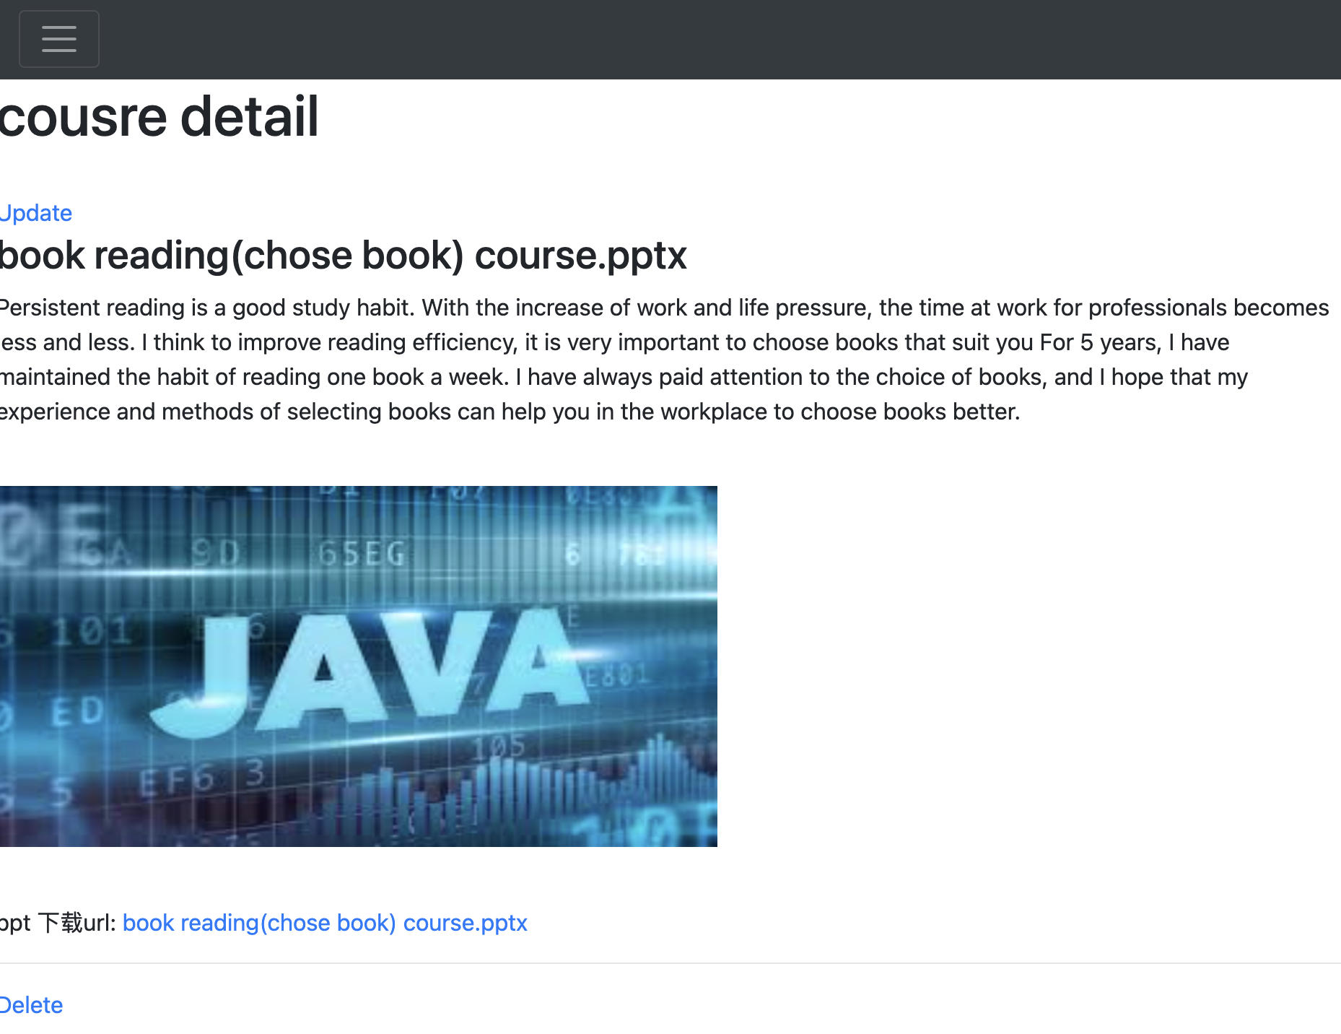
4. User Profile: The user dashboard should have a clean, modern design and provide an overview of the user's introduction in each course.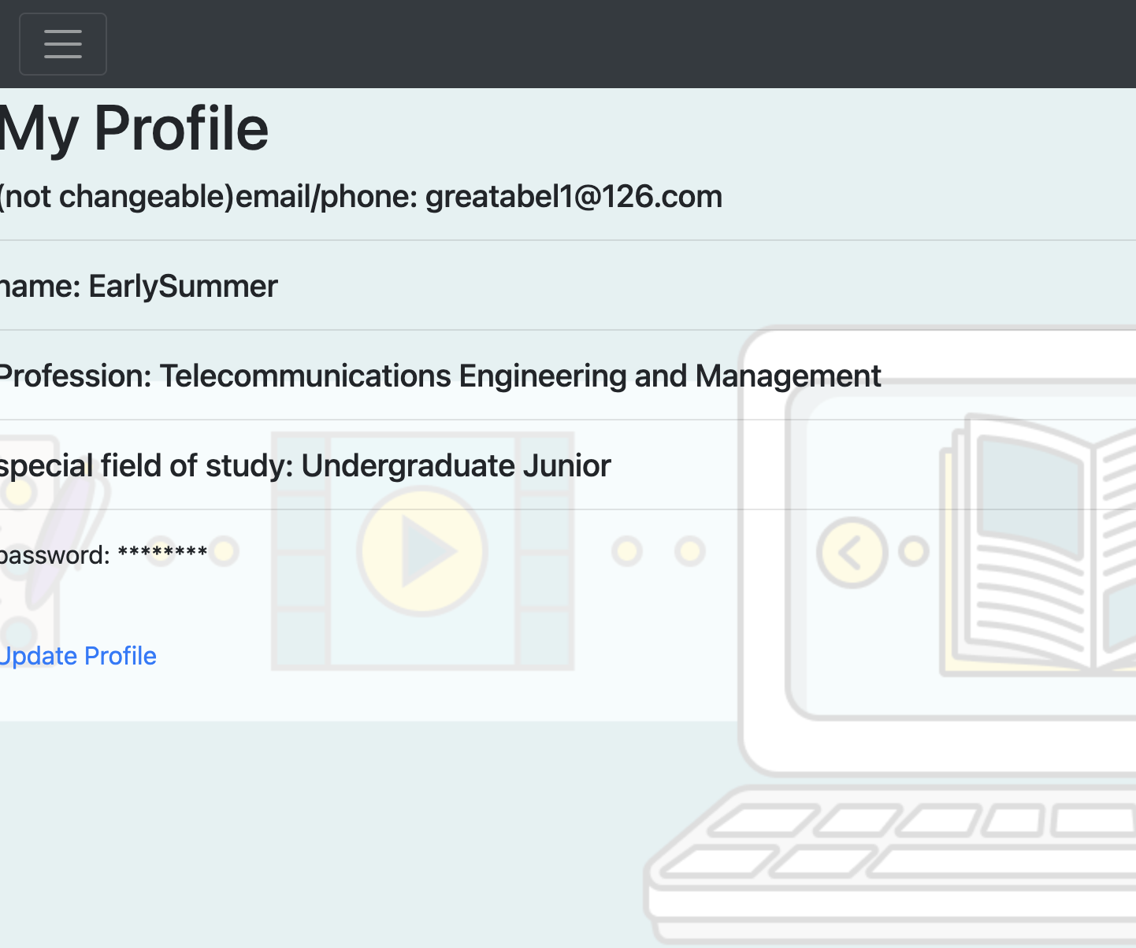
5. Comments Section: The comments section should be integrated into the lesson pages and allow users to leave comments and feedback on the course content. The comments should be moderated to ensure a positive and respectful learning environment.（这块还要补充 ）